Projekt „Brána jazyků otevřená“ získal finanční prostředky od Evropské unie
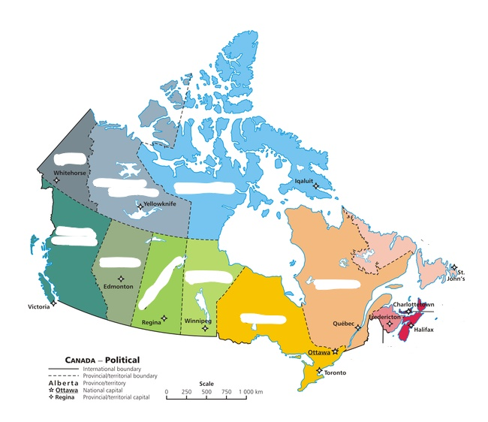
https://en.wikipedia.org/wiki/Canada
Canada
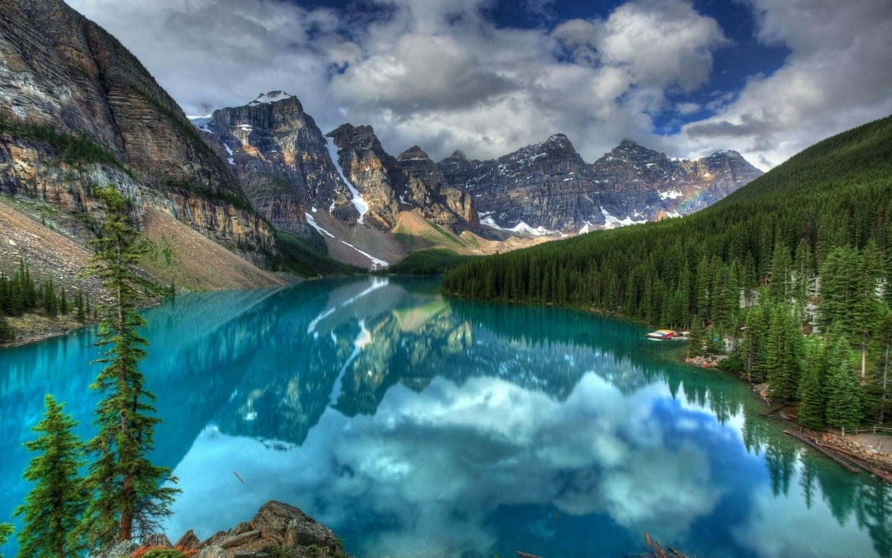
https://www.thousandwonders.net/Banff+National+Park
Introduction
Task : Give 5 expressions which characterize Canada the best (cooperate with your partner)
If you are not sure in English, give them in Czech.

Task: Name the main landforms in the picture above (find the NP in the map) Explain the formation of the peaks in the picture.

Task: Fill in the expressions below in the gaps

A land of ………. distances and ……. natural resources, Canada …………. a self-governing dominion in……., while retaining ties to the………… crown. Economically and technologically, the nation …….. developed in parallel with the US, its neighbor to the south across the world's longest ……………. border. Canada faces the political challenges of meeting public demands for quality improvements in ………… care, education, …………. services, and economic competitiveness, as …………. as responding to the particular concerns of predominantly ……………. Quebec. Canada also aims to develop its diverse ………… resources while maintaining its commitment to the environment.
https://www.cia.gov/library/publications/resources/the-world-factbook/geos/ca.html
1867 social vast has became international British rich health well francophone energy
My new words (I should understand):

Task: Using the atlas or the website write down the basic information about Canada
Area:
Population:
Capital:
Form of the country:
Political system:
Administrative division:
Head of the country:
International intergration:
Map skills task: Label all provinces and territories in the map above.
Notes:

